Part A:1:a
- Matched designs
K_{n}’(W/L)_{n}=k_{p}’(W/L)_{p}
K_{n}’ = miu_{n}.Cox=3.80x10^-10 A/V²
K_{p}’ = miu_{p}.Cox=8.46x10^-11 A/V²
W_{p} =4.04 μm
450/100=4.5
W_{n}=0.9 μm
W_{p}=4.05 μm
X1=3Lmin = 0.54 μm

Q_{n}: A_{s}=A_{d}= X₁W_{n}= 0.54 x 0.9 = 0.486 pm
P_{s}=P_{d}= 2X₁+2W_{n} = 2 x 0.54 + 2 x 0.9 = 2.88 μm
Q_{p}: A_{s}=A_{d} = X₁Wp = 0.54 x 4.04 = 2.182 pm²
P_{s}=P_{d}= 2X₁+2W_{p} = 2 x 0.54 + 2 x 4.04 = 9.16 μm

VTC:
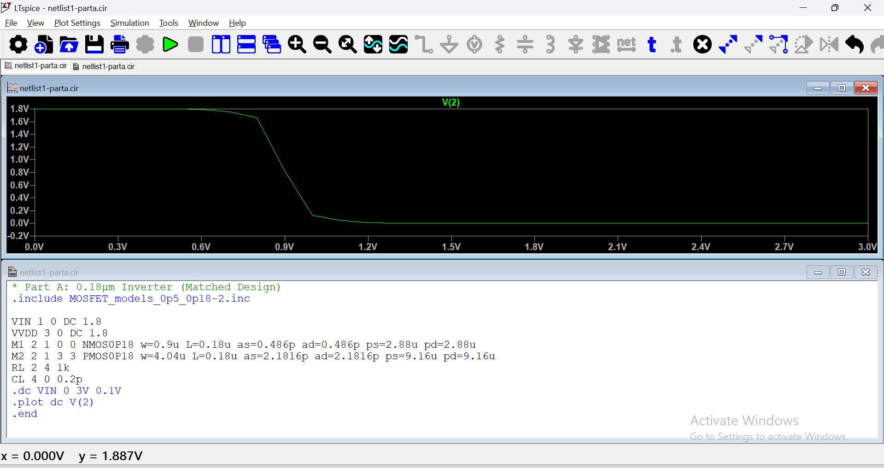

- Transfer characteristics can be seen. When Vin is low,Vout is high and vice versa.
- The graph has a slope of -1 twice
- This shows the inverter operation, In the low Vin range, the NMOS is off, and the PMOS is fully conducting. In the transition region, the NMOS enters saturation while the PMOS is in triode, resulting in the steep slope.

Supply voltage:
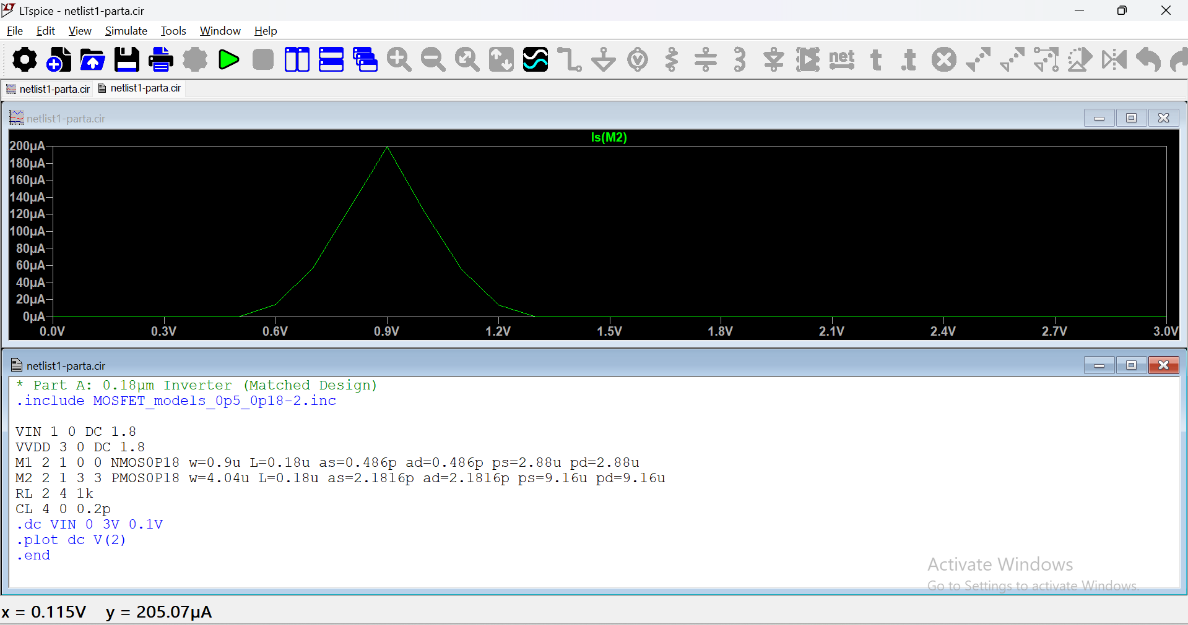
- The current coming out of the voltage source VDD is the same as source current of the PMOS inverter, so we can take it as the reference current.
- As Vin varies, we observe the current change. The peak is when both NMOs and PMOS are in saturation.

Part A-1-B:
P=n, so W_{n}=W_{p}=0.9µm.
VTC:
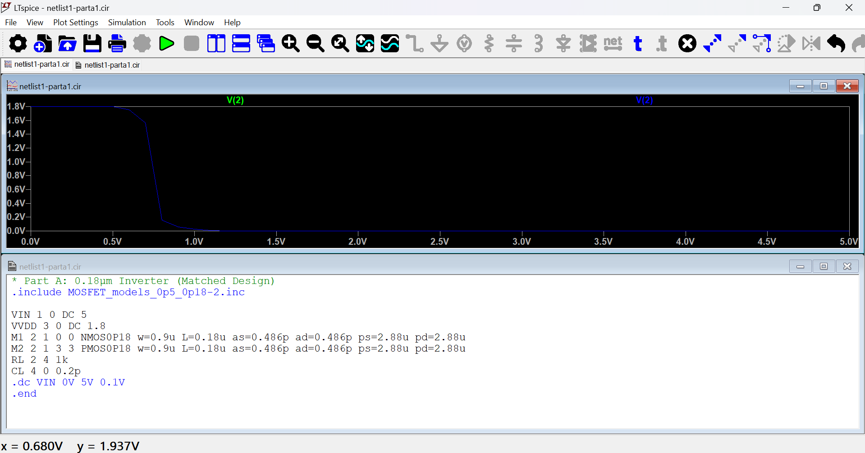
- Because of smaller dimensions of the transistor the graph is different in the transition region,
The supply current:
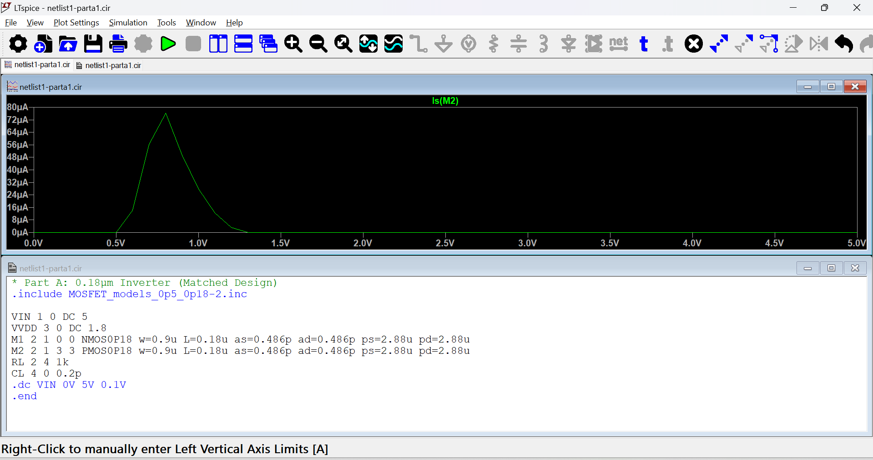
● The current profile is reduced due to the smaller dimension.

Part A-2:
Matched Design
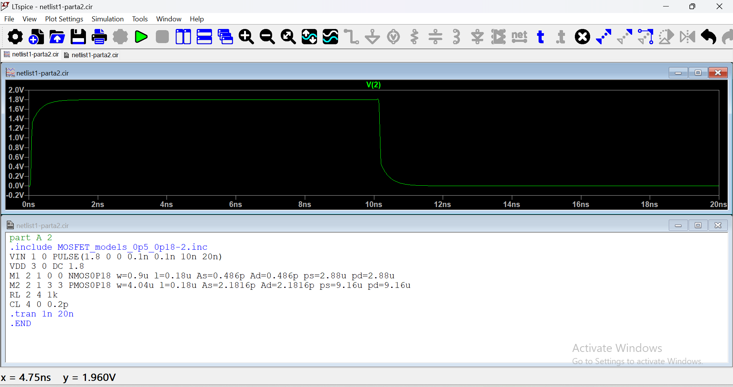
- Initially, the output is high at 1.8V at low input. This is because the NMOS is off and the PMOS is in the conducting state.
- The output moves to low when input increases. NMOS is on and PMOS is off.
- T_{plh} = 0.08ns, T_{phl} = 0.08ns. So T_{pd}= (T_{plh} + T_{phl}) = 0.08 ns

Minimum Area:
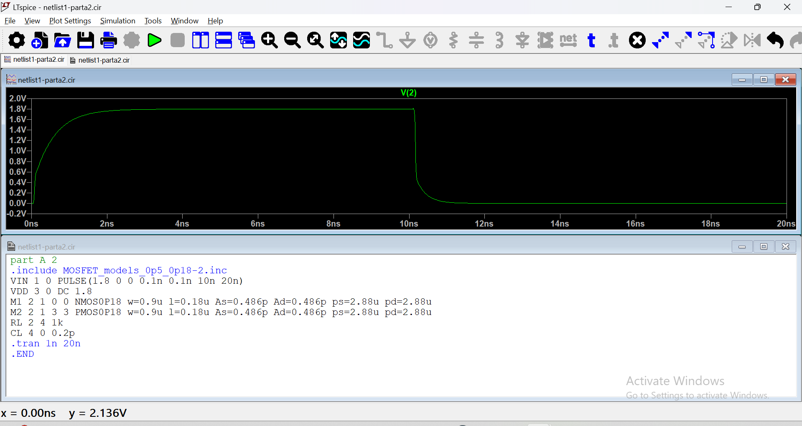
- Slower transition between states
- The transistors are smaller, which reduces their current driving capability I_{DS}
- More time to charge and Discharge
- T_{plh}= 0.2ns, T_{phl} = 0.1ns. So T_{pd}= (T_{plh} + T_{phl}) = 0.15 ns

Question 3:
1)a)
K_{n} ′=μ_{n}⋅C_{ox}=1.67×10⁻¹⁰ A/V²
K_{p} ′=μ_{p}⋅C_{ox}=4.17×10⁻¹¹ A/V²
L_{p}=L_{n}=0.5 μm
W_{n} is given as 1.25-μm
So W_{p} =5.00μm
X₁=3L_{min} = 1.5 μm

Q_{n}: A_{s}=A_{d}= X₁W_{n}= 1.5 x 1.25 =1.875 pm²
P_{s}=P_{d}= 2X₁+2W_{n}= 2 x 1.5 + 2 x 1.25 = 5.5 μm
Q_{p}: A_{s}=A_{d}= X₁W_{p} = 1.5 x 5 = 7.5 pm²
P_{s}=P_{d}= 2X₁+2W_{p}= 2 x 1.5 + 2 x 5 = 13.0 μm
VTC:
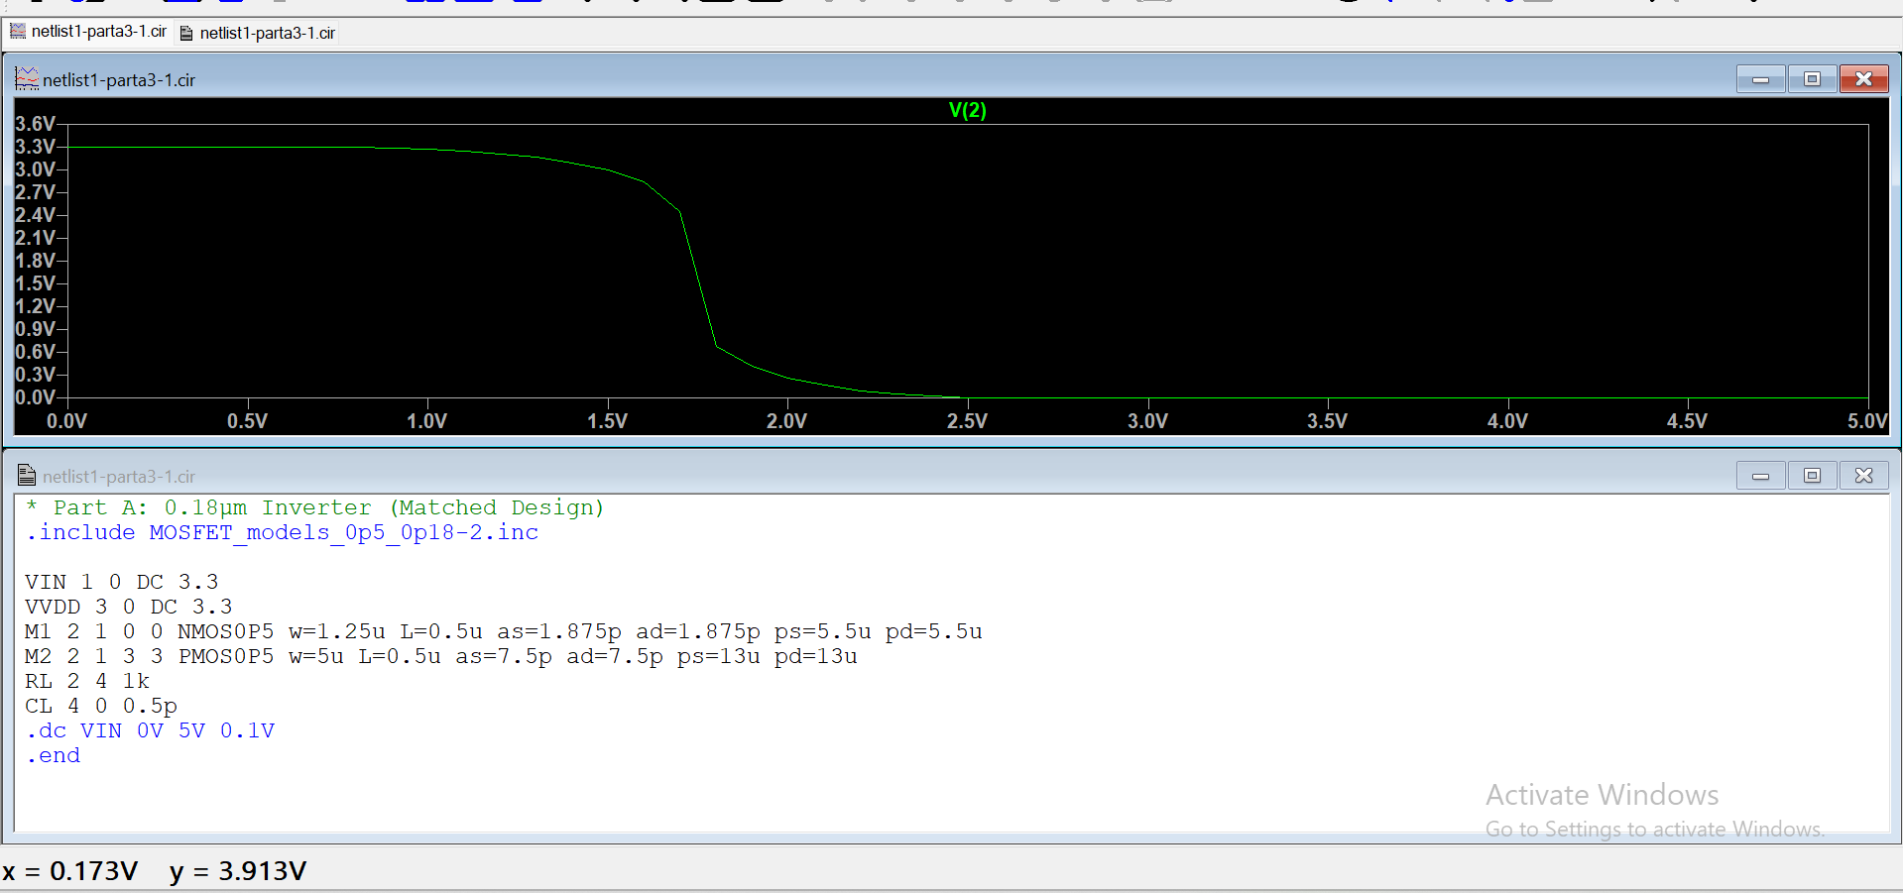
- The output voltage transitions from VDD (3.3 V) to 0 V as the input voltage increases from 0 V to 3.3 V.
- The balanced sizing of the PMOS and NMOS ensures that the switching threshold Vm is approximately at mid-supply (near VDD/2=1.65 V)

Supply Current:
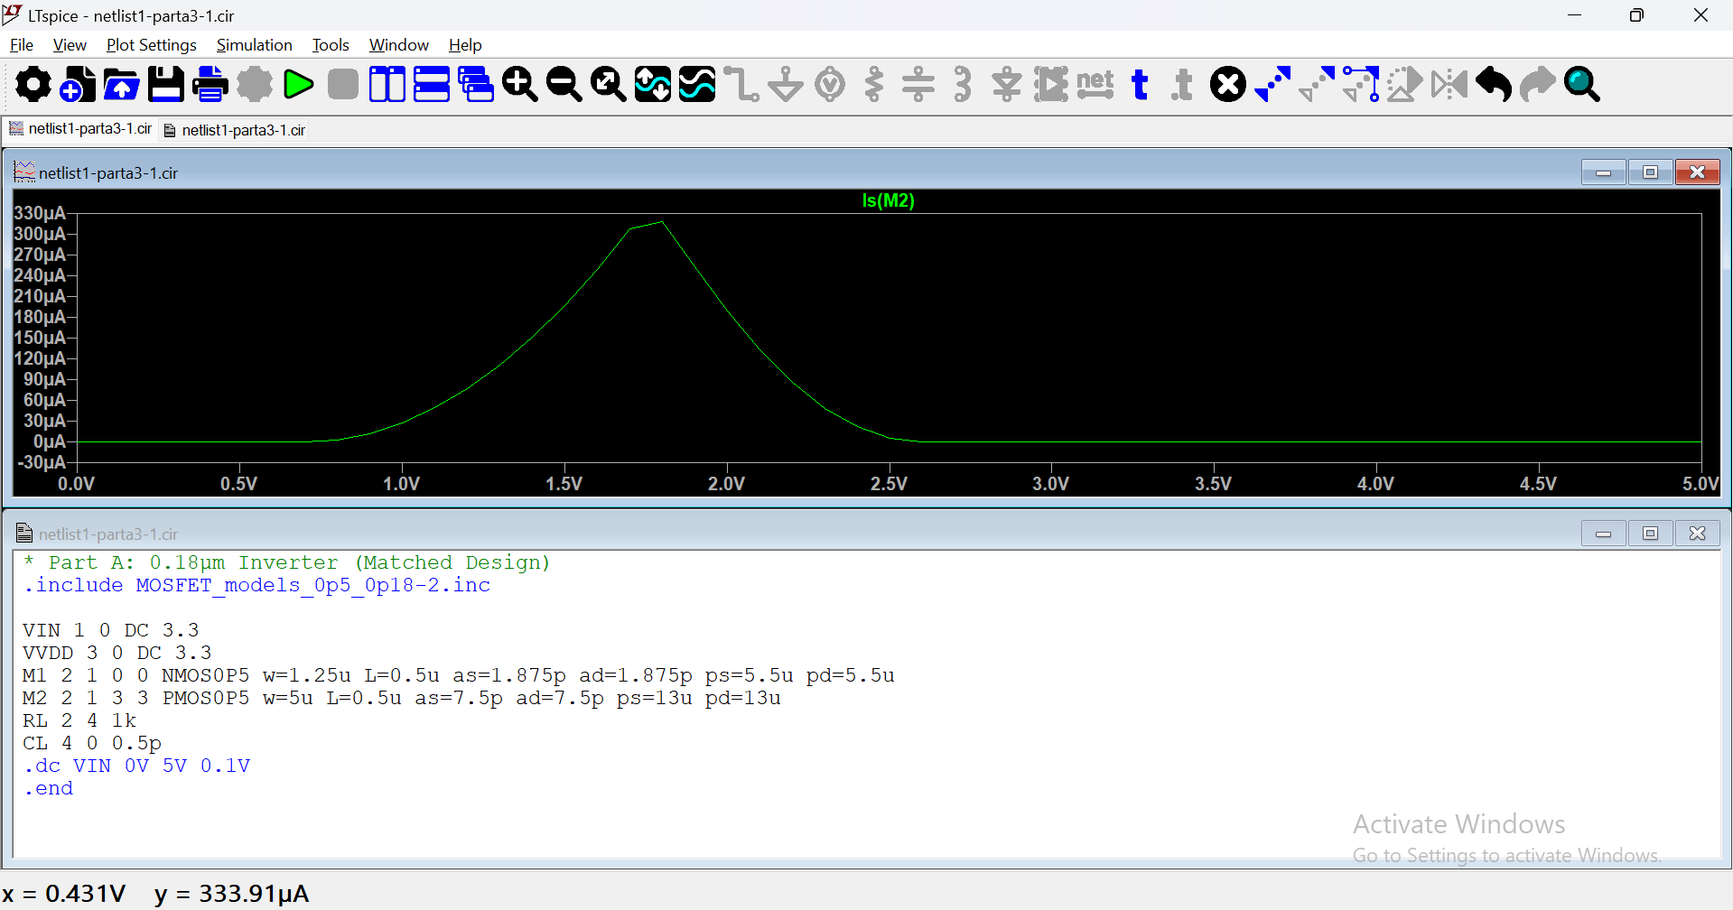

- At low Vin, PMOS is conducting, NMOS is off, and the current drawn is minimal.
- At VM, both transistors are in the saturation region, and a significant current flows through the inverter as PMOS and NMOS paths compete. This explains the peak in IDD
- At high Vin, NMOS is conducting, PMOS is off, and the current drawn is again minimal.

b)minimum area
For minimum area 𝑝 = 𝑛, so Wn=Wp=1.25 μm
- It can be seen that the graph is not as steep as the matched design.
- This is because the transistors are not matched because of the tradeoff between area and performance.
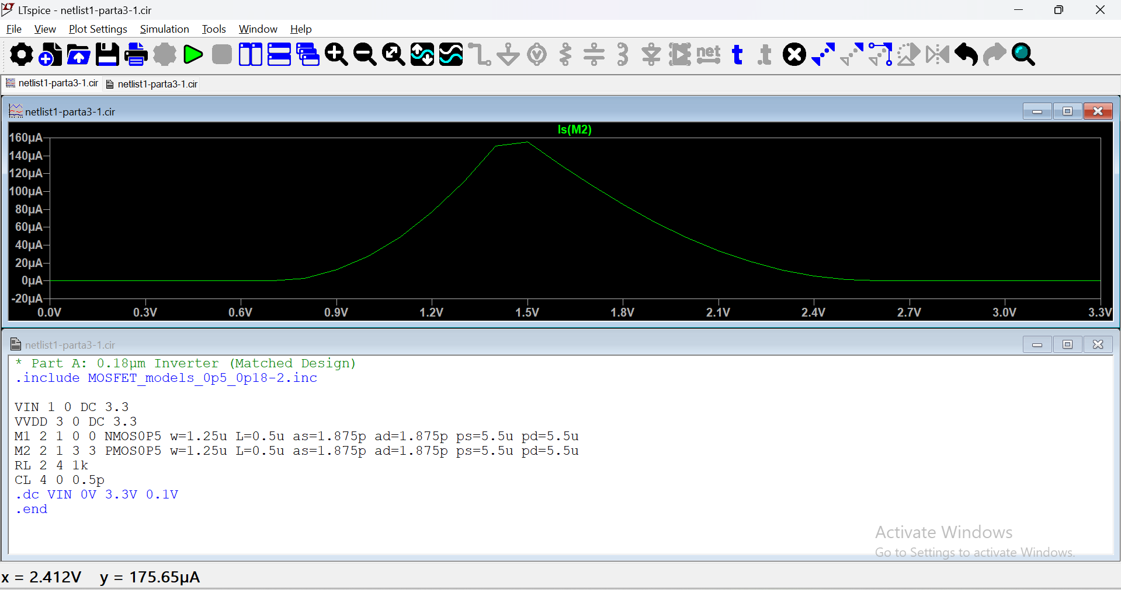

- Similar to the previous current graphs, the peak current happens when Vin is near Vdd /2 since both transistors are in saturation

2)a)
VTC:
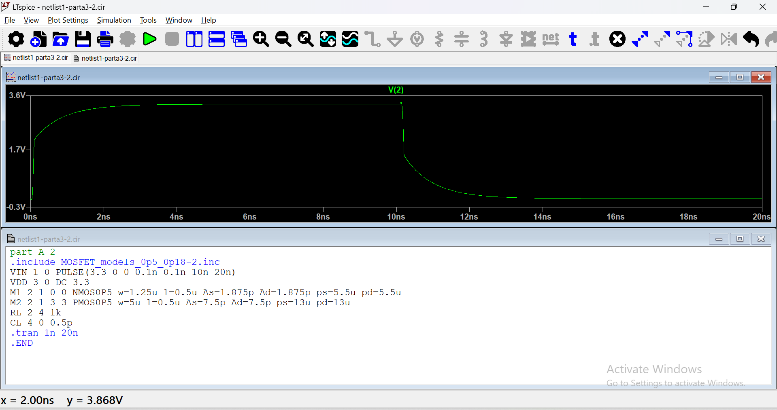
The graph is very steep with minimal propagation delay due to the matched design
T_{plh}= 0.096ns, T_{phl} = 0.1ns. So T_{pd}= (T_{plh} + T_{phl} ) = 0.098 ns

Minimum area:
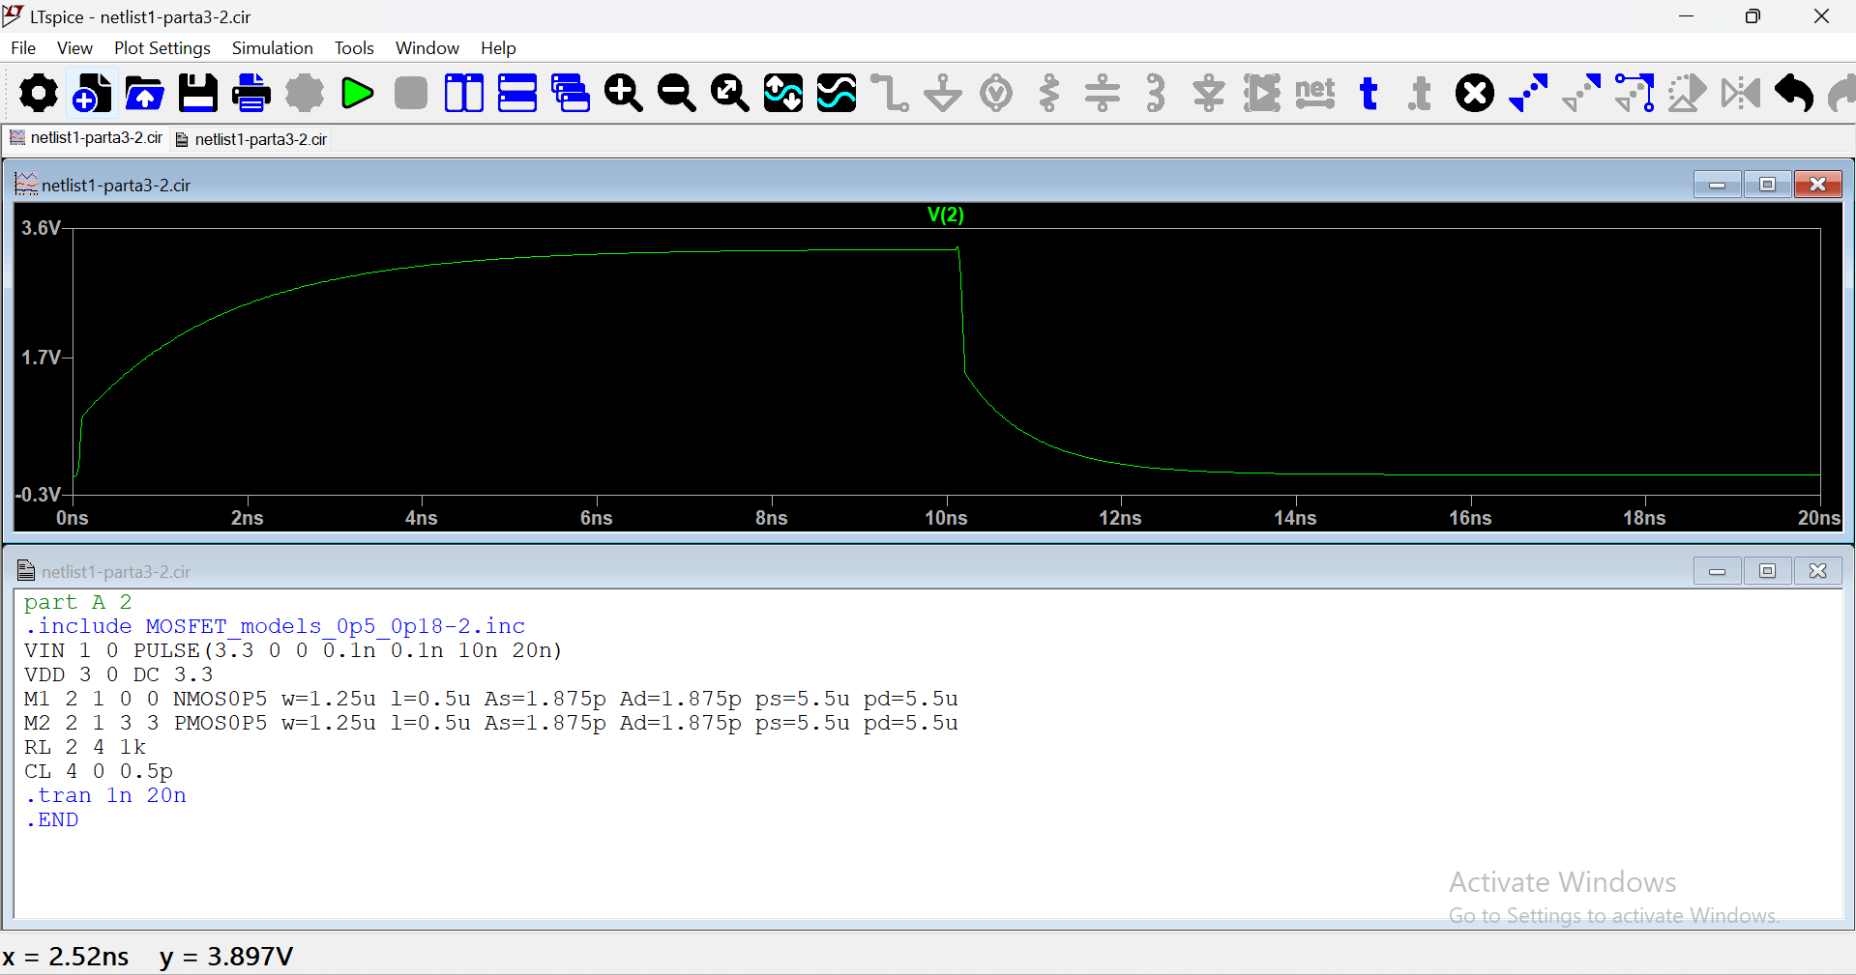

Transistors in the minimum-area design have lesser widths, increasing the resistance and slowing down the charging/discharging of the load capacitor. This can be seen in the increased time taken to go from low to high.
T_{plh}= 0.78ns, T_{phl} = 0.09ns. So T_{pd}= (T_{plh} + T_{phl} ) = 0.435 ns

